**Software Requirement Specification Document for “SALMANS”**

**Team members:**

*Chinedu Urbanus Ugwu - 610119*

*John Imhonikhe Lawal - 610098*

*Mohammed Seud - 109362*

**GitHub Link For The Project**: <https://github.com/JohnLawal/SALMANS>

**USE CASE MODEL**

**Use Case Diagram**

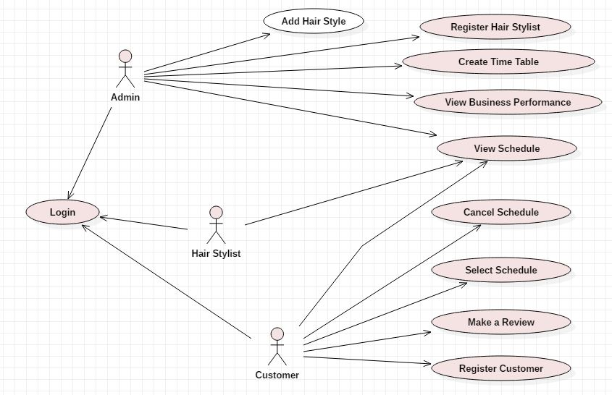

**Use Case Descriptions**

|  |  |  |
| --- | --- | --- |
| **Use Case Number:** 1 | | |
| **Name:** Registering A NewHair Stylist | | |
| **Brief description:** This use case allows the admin to create profiles for hair stylists | | |
| **Actors:** Admin | | |
|  | | |
| **Preconditions** | | |
| The admin must be logged in to the system | | |
| **Flows of Events:** | | |
| **1. Basic Flows:** | | |
| **1.1.0 Create Hair Stylist Profile** | | |
| **Step** | **User Actions** | **System Actions** |
| 1 | The admin calls the create hairstylist profile command | The system displays the hairstylist profile form with the fields for full name, email, and password and seat number. |
| 2 | The admin fills out the form and requests the system to save the details. | The system verifies that there’s no other profile in the database with the same email address and seat number and saves the hairstylist and returns the success message on success or a fail message in case of failure. In case another profile exists with the email address, the system returns the message indicating a duplicate entry exists. |
| **Post conditions** | | |
| The hairstylist profile is persisted in the system | | |
|  | | |
| **Business Rules** | | |
| No duplicate hair stylist profiles. A unique profile is identified by email address.  The seat number must not be assigned to another hairstylist already. | | |
|  | | |
| **Use Case Number:** 2 | | |
| **Name:** Registering A NewCustomer | | |
| **Brief description:** This use case allows the customers to create profiles for themselves. | | |
| **Actors:** Customer | | |
|  | | |
| **Flows of Events:** | | |
| **1. Basic Flows:** | | |
| **1.1.0 Create Customer Profile** | | |
| **Step** | **User Actions** | **System Actions** |
| 1 | The customer calls the create profile command | The system displays the customer profile form with the fields for full name, email, and password. |
| 2 | The customer fills out the form and requests the system to save the details. | The system verifies that there’s no other profile in the database with the same email address and saves the customer and returns the success message on success or a fail message in case of failure. In case another profile exists with the email address, the system returns the message indicating a duplicate entry exists. |
| **Post conditions** | | |
| The customer profile is persisted in the system | | |
|  | | |
| **Business Rules** | | |
| No duplicate customer profiles. A unique profile is identified by email address. | | |
|  | | |
| **Use Case Number:** 3 | | |
| **Name:** Customer Selects Schedule | | |
| **Brief description:** This use case allows the customers to schedule appointments. | | |
| **Actors:** Customer | | |
|  | | |
| **Preconditions** | | |
| The customer must be logged in to the system | | |
| **1. Basic Flows:** | | |
| **1.1.0 Select Schedule** | | |
| **Step** | **User Actions** | **System Actions** |
| 1 | The customer calls the select schedule command | The system displays the list of available dates and times with open seats. |
| 2 | The customer selects an available date and submits | The system verifies that the date is available and displays a screen for the user to select or provide their style and choose a seat number. |
| 3 | The customer selects or provides their desired style and seat number and submits. | The system verifies that the seat number is available and proceeds to save the customers selection. |
| **Post conditions** | | |
| The customer's schedule is persisted in the system.  An email confirmation is sent to the customer.  The date and seat is now made unavailable for further selection. | | |
|  | | |
| **Business Rules** | | |
| No duplicate assigning of seats, dates and times. | | |
|  | | |
| **Use Case Number:** 4 | | |
| **Name:** Customer Cancels Schedule | | |
| **Brief description:** This use case allows the customers to cancel their scheduled appointments. | | |
| **Actors:** Customer | | |
|  | | |
| **Preconditions** | | |
| The customer must be logged in to the system.  The customer must have an existing appointment/schedule. | | |
| **1. Basic Flows:** | | |
| **1.1.0 Cancel Schedule** | | |
| **Step** | **User Actions** | **System Actions** |
| 1 | The customer calls the cancel schedule command | The system verifies that the customer has a schedule and updates the seat selected to available. |
| **Post Conditions** | | |
| The customer's schedule is updated in the system.  An email confirmation is sent to the customer.  The date and seat is now made available for selection. | | |
|  | | |
| **Business Rules** | | |
| No cancelling of schedules that do not exist for that user. | | |
|  | | |
| **Use Case Number:** 5 | | |
| **Name:** View Schedule | | |
| **Brief description:** This use case allows the customers to view their personal schedule. It allows hairstylists view their assigned schedules. It allows the admin view all assigned schedules. | | |
| **Actors:** Customer, Hair Stylists, Admin | | |
|  | | |
| **Preconditions** | | |
| The actor must be logged in to the system. | | |
| **1. Basic Flows:** | | |
| **1.1.0 Customer View Schedule** | | |
| **Step** | **User Actions** | **System Actions** |
| 1 | The customer calls the view schedule command | The system retrieves the schedules and details for this member only and displays it on the screen. |
| **1.1.1 Hair Stylist View Schedule** | | |
| **Step** | **User Actions** | **System Actions** |
| 1 | The hairstylist calls the view schedule command | The system retrieves the schedules assigned to this hairstylist only and displays it on the screen. |
| **1.1.1 Admin View Schedules** | | |
| **Step** | **User Actions** | **System Actions** |
| 1 | The admin calls the view schedules command | The system retrieves appointed schedules and displays it on the screen. |
|  | | |
| **Use Case Number:** 6 | | |
| **Name:** View Business Performance | | |
| **Brief description:** This use case allows the admin to view summary information about his business. | | |
| **Actors:** Admin | | |
|  | | |
| **Preconditions** | | |
| The admin must be logged in to the system. | | |
| **1. Basic Flows:** | | |
| **1.1.0 View Customer Reviews** | | |
| **Step** | **User Actions** | **System Actions** |
| 1 | The admin calls the view customer reviews command. | The system retrieves current customer reviews and displays them on the screen. |
| **1.1.1 View Summary Information** | | |
| **Step** | **User Actions** | **System Actions** |
| 1 | The admin calls the view summary information command. | The system retrieves summary information and displays them on the screen. |
|  | | |
| **Use Case Number:** 7 | | |
| **Name:** Create Time Table | | |
| **Brief description:** This use case allows the admin to specify business hours and available dates. | | |
| **Actors:** Admin | | |
|  | | |
| **Preconditions** | | |
| The admin must be logged in to the system. | | |
| **1. Basic Flows:** | | |
| **1.1.0 Enter Available Dates and Time** | | |
| **Step** | **User Actions** | **System Actions** |
| 1 | The admin calls the create time table command. | The system displays the form for specifying available dates and times on the screen. |
| 2 | The admin enters the available dates and times and submits the form. | The system stores the information in the database |
| **Post Conditions** | | |
| The dates are now displayed as available and customers can select those dates for appointment. | | |
|  | | |
| **Use Case Number:** 8 | | |
| **Name:** Add A New Hair Style | | |
| **Brief description:** This use case allows the admin to add new hairstyles to the system | | |
| **Actors:** Admin | | |
|  | | |
| **Preconditions** | | |
| The admin must be logged in to the system | | |
| **Flows of Events:** | | |
| **1. Basic Flows:** | | |
| **1.1.0 Add Hair Style** | | |
| **Step** | **User Actions** | **System Actions** |
| 1 | The admin calls the add hairstyle command | The system displays the hairstyle form. |
| 2 | The admin fills out the form and requests the system to save the details. | The system verifies that there’s no other hairstyle in the database  with the same name and saves the hairstyle and  returns the success message on success or a fail message  in case of failure. In case another hairstyle exists with  the name, the system returns the message indicating a  duplicate entry exists. |
|  | | | The admin calls the create hairstylist profile command | The system displays the hairstylist profile form with the fields for full name, email, and password and seat number. |
| **Post conditions** | | |  |  |
| The hairstyle is persisted in the system | | |  |  |
|  | | |  |  |
| **Business Rules** | | |  |  |
| No duplicate hair styles. A unique hairstyle is identified by name. | | |  |  |
|  | | |  |  |

**SUPPLEMENTARY SPECIFICATION**

The system will fulfil several non-functional requirements including:

**Scalability –** The application will scale to accommodate any number of users as customers or hairstylists are registered.

**Security –** The application will ensure that details of the entire users are secure and free from external manipulation.

**User Friendliness –** The application will be developed in a way that it will be easily usable by its users.

**Performance –** The application will be developed to perform optimally.

**Availability –** The application will be able available for 99.9% of the time.

**GLOSSARY**

**Hairstylist -** is a person whose occupation is to cut or style hair in order to change or maintain a person's image.

**Schedule** - a timetable for carrying hairstyling in the, stating date and time.

**Hairstyle -** A hairstyle refers to the styling of hair, usually on the human scalp. Sometimes, this could also mean an editing of facial or body hair.